**FOR COMMENTS**

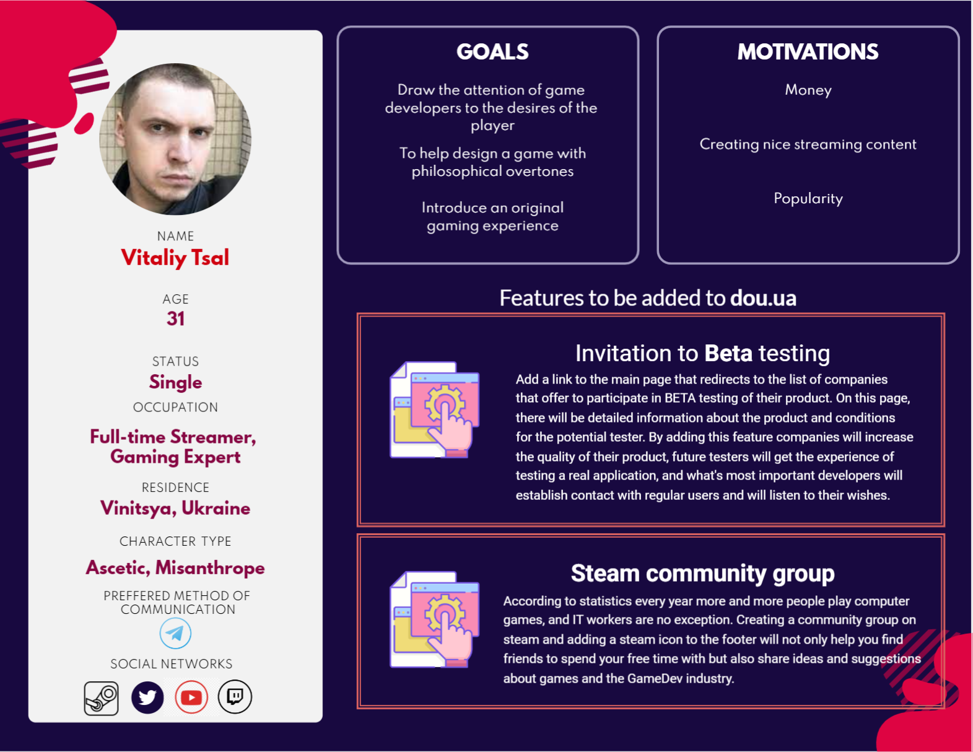

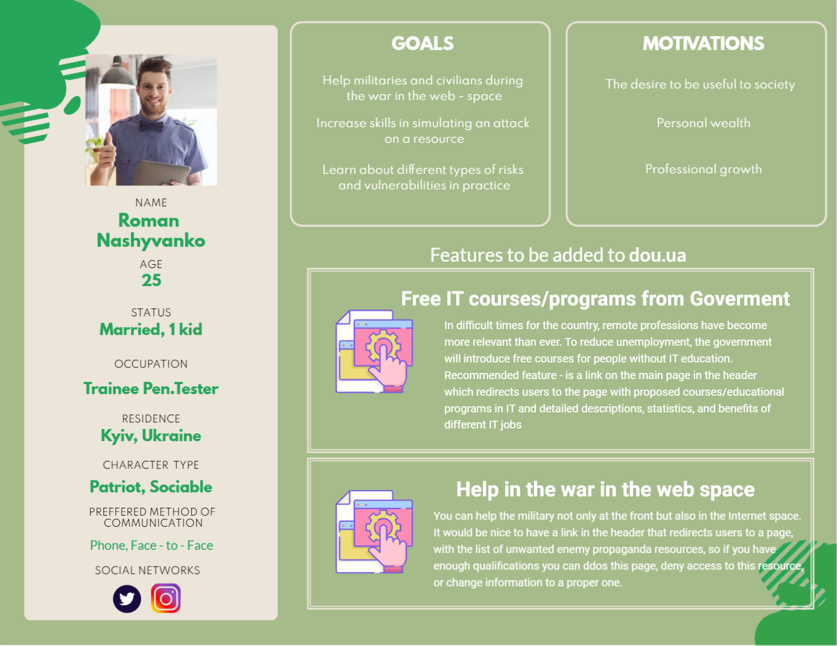

**All user stories are related to 1 person's features.**

| **Invitation to BETA testing** | | |
| --- | --- | --- |
| **№** | **User story** | |
| 1. | As a user (trainee QA) I want to have a list of companies that offer to participate in beta testing of their product so that, I can improve my testing skills | |
| 2. | As a user (trainee QA) I want to have a link to a video review of the product that is going to be tested so that, I can better understand its details and requirements. | |
| 3. | As a company manager I want to see all candidates who applied so that, I can select the most motivated | |
| 4. | As a user (trainee QA) I want to receive an email message after the company has considered my candidacy so that, I can understand if it was accepted/rejected and why? | |
| 5. | As a company manager I want the application to include the field required to fill in so that, I can find out the motivation of the tester. | |
| 6. | As a site administrator, I want to remove a company's offer if the company does not have a license so that, users are prevented from taking part in unlicensed companies' events. | |
| **Steam community group** | | |
| **№** | **User story** | |
| 1. | As a site - user I want to be redirected straight to the Steam application if it's installed on my machine, not to the web page so that I will be able to use all the application benefits. | |
| 2. | As a site - administrator I want to be able to make link unclickable if a group is on maintenance so that users will be unable to see unfinished features. | |
| 3. | As a site - user I want to be able to link my Steam account to my Dou account, so that, I can participate in events for users with linked accounts only. | |
| 4. | As a site - administrator I want to be able to forbid users with bad decency to click on the link so that, aggression in chats is prevented. | |
| 5, | As a site - user I want to have a toolpit when placing the cursor on the icon so that, I can find out which company the logo is. | |